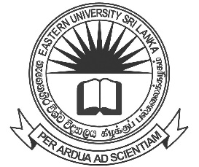

EASTERN UNIVERSITY, SRI LANKA
NOTICE

COLLECTION OF DEGREE CERTIFICATES
GENERAL CONVOCATION-2023

FACULTY OF HEALTH CARE SCIENCES

Bachelor of Medicine and Bachelor of Surgery graduates who were conferred degrees on General Convocation-2023 held on 07th October 2023 can collect their Degree Certificates from the Academic Affairs Department on 23rd November 2023 from 10.00 a.m. to 4.00 p.m. by producing their Student Identity Card and Students Record Book.

- Graduands are requested in person to collect their Degree Certificates. Degree Certificates will not be issued to another person.

- Degree Certificates will be issued to those who completed the No-Claim with the respective Faculty.

Mrs. N. Nirumithan
Deputy Registrar/ Academic Affairs
for Registrar

10.11.2023

